**Agastya’s Memorable Graduation and Lighting ceremony**

On December 23, 2023, as the doors of Tagore Hall at Agastya Academy swung open, a deep sense of anticipation and excitement enveloped both us, the graduating students, and our parents. The Graduation and Lighting Ceremony ended up becoming one of our core memories of this lifetime.

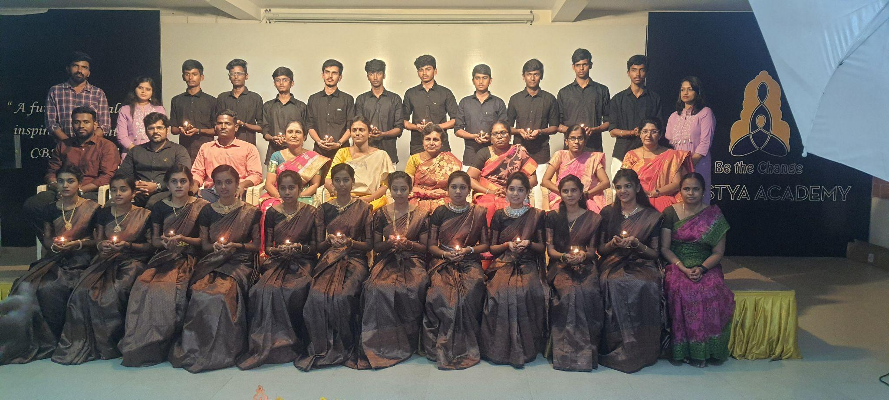

Our teachers welcomed us with open arms, much similar to the hype of entering a marriage hall, and bestowed upon us a warm welcome that set the tone for a memorable evening. The walls adorned with photo collages took us down memory lane, showcasing snapshots from our previous events and years. Amidst the nostalgia, we gathered with friends, reminiscing about cherished moments that defined our time at Agastya.

[Click here for more……..](https://www.agastyaacademy.edu.in/post/agastya-s-memorable-graduation-and-lighting-ceremony)